A Showdown of Classification Models to Predict Heart Disease Risk

Sona Shaukath (T00710785)

**Abstract**

**Heart Disease is a health issue resolved with early identification, prevention and treatment. This study is a stepping stone to classify heart disease risk based on other variables, Body Mass Index (BMI), Smoking, Physical Health, Mental Health, and Sex, to name a few. This study aids in predicting heart disease based on the five classification models. In this study, comparing five classification models, namely, K-Nearest Neighbours (KNN), Support Vector Machine (SVM), Random Forest, Decision Tree and Naive Bayes, with the help of "F1-Score", helps to identify which classification model works best for the data. This imperative study is commencing further study on this data to understand, analyse and prevent Heart Disease Risk based on available variables. My study sheds light on which classification models are best at predicting the risk of heart disease by contrasting several models. In order to identify individuals who are more likely to develop heart disease, this information can be used to create risk assessment systems that are more precise.**

**Keywords**

**Classification, Machine Learning, F1-Score, Heart Disease Risk**

1. **INTRODUCTION**

# The early detection and prevention of heart disease play a vital role in treating cardiovascular disease. Being a significant public health issue, research and project in this direction are a step closer to a better analysis of the disease. In this fast pace technological world, Machine learning techniques come forward as one of the best methods to identify and predict heart diseases. To further dwell on this, classification methods shone in the field of health care in order to diagnose several medical conditions.

# This study uses classification methods to predict heart disease risk based on several factors, including BMI (Body Mass Index), Physical Health, Mental Health, General Health, Sex, Age, and many more factors. The sole purpose of this imperative study is to apply five classification models: K-Nearest Neighbors (KNN), Support Vector Machine (SVM), Random Forest, Decision Tree and Naive Bayes, to predict the heart disease risk using the evaluation metrics F1-score. In addition, this study also aids in identifying which classification methods work best to predict heart disease risk.

1. **DATA**

The data set used for this study is derived from the dataset of CDC and is a major part of the Behavioral Risk Factor Surveillance System (BRFSS), which conducts annual telephone surveys to gather data on the health status of U.S. residents. The original dataset consists of 401,958 rows and 279 columns. From this large dataset, a smaller dataset was derived with 319,795 rows and 18 columns in Kaggle [1]. This dataset from Kaggle was my source for this study.

From 18 columns in this dataset, “HeartDisease” is the response variable which is a categorical variable with Yes or No values. The other 17 variables are considered as predictor variables which aids in identifying the best classification model to predict the heart risk. The other variables include:

1. “BMI” (Body Mass Index) – continuous variable with 1491 unique values.
2. “Smoking” – Categorical variable with 2 unique values “Yes” or “No” which denoted whether a person smokes or not.
3. “AlcoholDrinking” – Categorical variable with 2 unique values “Yes” or “No” which denotes whether the person drink alcohol or not.
4. “Stroke” – Categorical variable with 2 unique values “Yes” or “No” which implies whether a person had a stroke or not.
5. “PhysicalHealth” – variable with 30 unique values.
6. “MentalHealth” – variable with 30 unique values.
7. “DiffWalking” – Categorical variable with 2 unique values “Yes” or “No” which implies whether the person has a difference in walking or not.
8. “Sex” – Categorical variable with 2 unique values “Male” or “Female”.
9. “AgeCategory” –variable which is denoted in buckets of age.
10. “Race” – Categorical variable with 6 unique values.
11. “Diabetic” – Categorical variable with 5 unique values “No”, “No, borderline diabetes”, “Yes(during pregnancy)”, and “Yes”
12. “PhysicalActivity” – Categorical variable with 2 unique values “Yes” or “No” which implies whether the person does physical activities or not.
13. “GenHealth” – Categorical variable with 5 unique values “Poor”, “Fair”, “Good”, “Very Good” and “Excellent”.
14. “SleepTime” –variable which is denotes the sleeping time of a person.
15. “Asthma” – Categorical variable with 2 unique values “Yes” or “No” which implies whether the person has Asthma or not.
16. “KidneyDisease” – Categorical variable with 2 unique values “Yes” or “No” which implies whether the person has/had kidney disease or not.
17. “SkinCancer” – Categorical variable with 2 unique values “Yes” or “No” which implies whether the person has/had skin cancer or not.

Due to the low computational resources (8 GB RAM) on the local machine, the training of the models took longer computational time than expected. To utilize all the samples, the computational memory of 32 GB RAM is required. Hence, due to the computational limitation, I initially sampled 10000 rows to train the models and get the desired results.

1. **EXPLORATORY DATA ANALYSIS**

The GitHub link for the R Code, .csv file is <https://github.com/sonashaukath22/DASC-5420-Final-Project>.

*Data Pre-processing*

1. *Removal of Null Values:* The null values were removed from the dataset using the “na.omit” function in R. This aids in not considering the rows that has null values.
2. *Conversion of variable with String Values into Numeric Values:* 
   1. The variables which contained string values were converted to numeric values. The variables “HeartDisease”, “Smoking”, “AlcoholDrinking”, “DiffWalking”, “PhysicalActivity”, “Asthma” , “KidneyDisease”, and “SkinCancer” with values “Yes” or “No” were converted to “0” for “No” and “1” for “Yes”.
   2. The variable “Sex” was converted to “1” for “Male” and “0” for “Female”.
   3. “SleepTime” variable was converted to categorical variable by taking the values greater than the median of the values in “SleepTime” to “1” and the rest to “0”.
   4. The variable “GenHealth” was converted into numeric values with “0” for “Poor”, “1” for “Fair”, “2” for “Good”, “3” for “Very good” and “4” for “Excellent”.
   5. “Diabetic” was converted into numeric values with “0” foe “No”, “1” for “No, borderline diabetes”, “2” for “Yes (during pregnancy)” and “3” for “Yes”.
3. *Checking for outliers:* Figure 1 shows that the variable “BMI” has outliers.

*Figure 1. Boxplot of BMI against Heart Disease (Before Removal of Outliers)*

The IQR (Interquartile Range) is one of the very commonly used method to remove outliers [2]. This involves the calculation of difference between the third and first quartile of the dataset and multiplying this difference with a constant (here 1.5) to calculate a threshold. The datapoints that fall outside this calculated threshold are outliers which are removed.

Figure 2 shows the boxplot of BMI after the removal of outliers.

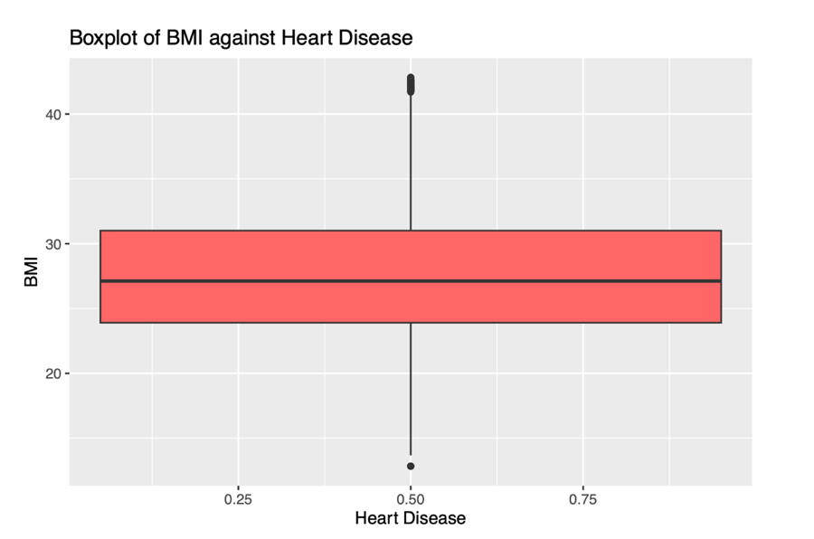

*Figure 2. Boxplot of BMI against Heart Disease (After Removal of Outliers)*

1. *Scaling of continuous variable:* The continuous variable “BMI” was scaled using “scale()” function. The function find the difference of each observation with the mean of the variable and find the product by standard deviation [3].

*Data Visualisation*

1. *Histogram of “HeartDiseae”:* Figure 3 shows the histogram of “HeartDisease” against frequency. This histogram helps us to identify whether the response variable, “HeartDisease” is balanced or imbalanced. Checking of balance is crucial since this step allows us to understand which metric is best for the classification problem.

*Figure 3. Histogram of Heart Disease*

From Figure 3, it is evident that the response variable is imbalanced due to which I’m aligned to choose F1-score as my calculation metric.

1. *Histogram of BMI:* The histogram of BMI aids to understand how the values in BMI looks like.

*Figure 4. Histogram of BMI*

With the help of Figure 4, we can see that the values in BMI are skewed towards the right.

1. *Plot Grid of Boxplots of Categorical Variables:* Figure 5 helps to visualise the remaining categorical variables with the help of boxplots.

*Figure 5. Plot Grid of Boxplots of Categorical Variables*

1. **METHODOLOGY**

This study emphasis on comparing different classification models to predict Heart Disease Risk. Before performing any of the classification model training, the dataset sampled was divided into 70% training and 30% testing using the “createPartition()” function in the “caret” package. The training set is used to train the models, while the testing set is employed to make predictions. Finally, the performance evaluation metric for measuring test performance is calculated using the predictions. The five classification models for this project and they are:

1. *K-Nearest Neighbours (KNN) Classifier:* The algorithm focuses on locating k nearest neighbours of a data point and assigning it to the class with the majority [4]. For this dataset, the KNN method applies the in-built package "caret", which includes the "train()" function [5]. In addition, the train() function contains the parameter "method", which can be assigned to "knn" to train the model using the training data. Finally, the results were predicted using the "predict()" function. To attain the F1 score, the built-in package "ML metric" was used, and the Confusion Matrix was printed using the "confusionMatrix()" function.
2. *Support Vector Machine (SVM) Classifier:* The algorithm works by separating the data into two classes by finding the hyperplane that maximizes the margin between these classes [6].

The SVM classifier was used on the dataset using the “svm()” function from the in-built package “e1071”. This is the easiest method to train the model using the training data. The prediction is performed using the test data. The F1 Score is calculated along with the Confusion Matrix.

1. *Random Forest Classifier:* Many decision trees are combined in the Random Forest Classifier ensemble approach to create a more precise and reliable prediction [7]. I used the in-built package “randomForest” to use the “randomForest()” function to train the model. Whereas the predict() function from caret package was used to make predictions using the test data. The F1 Score was printed along with the confusion matrix.
2. *Decision Tree Classifier:* A decision tree is a model that resembles a tree and represents a set of classification rules[8]*.* For this classification method we use the built-in “rpart” package and the function “rparr()” to train the model. While predicting the result we “type = class” to predict the results using the test data. The confusion Matrix and the F1-score is printed.
3. *Naïve Bayes Classifier:* Naive Bayes Classifier is based on Bayes' theorem, which asserts that the likelihood of the evidence given the hypothesis and the prior probability of the hypothesis are multiplied together to determine the probability of the hypothesis given the observed evidence [9].The “naivebayes” package is used to perform Naïve Bayes Classification. Here the “naiveBayes()” function is used train the model using the training data. Like in other models the predictions are made using “predict()” function. The F1- Score and the confusion matrix is printed.

The F1-Scores of all five classification models along with their names is loaded into a table which is used to create a histogram to clearly understand the difference between the F1-Scores of each model.

1. **RESULTS**

The results of each classification models is printed using its confusion Matrix results and the F1-Score. The F1-score, which combines precision and recall into a single statistic, is the harmonic mean of these two metrics [10]. When you have an imbalanced dataset, where the proportion of instances in one class is significantly higher than the other, it is an excellent statistic to use to balance the weights assigned to precision and recall.

From Figure 3, we came to a conclusion that the response variable is imbalanced due to which the F1- Score is the best decision metric in this scenario.

1. *KNN Classifier Results:* The KNN Classifier gave a F1-Score result of **0.9539521**.
2. *SVM Classifier Results:* The SVM Classifier gave an F1-Score of **0.9560360**.
3. *Random Forest Classifier Results:* The Random Forest Classifier resulted in an F1- Score of **0.9558131**.
4. *Decision Tree Classifier Results:* The F1- Score of Decision Tree Classifier was **0.9557235**.
5. *Naïve Bayes Classifier Results:* The Naïve Bayes Classifier has a F1- Score of **0.9120470**.

The F1-Scores were used to create a data frame using the model names (Figure 6). The data frame was then used to create a histogram in Figure 7. This aids in understanding which classification models works best for this data set.

*Figure 6. F1-Scores of Classification Models*

*Figure 7. Histogram for the Comparison of F1-Scores*

1. **CONCLUSION**

The initial goal of this study was to determine which classification model is the most effective at predicting the risk of heart disease in the dataset. Following the development of models and forecasts, it was determined that the Support Vector Machine performs the best at predicting the risk of heart disease. This is because the F1-Score provided by the Support Vector Machine Classifier, which was the highest of all F1-Scores, was **0.9560360**.

Also, it was noted that all of the F1-Scores were higher than 0.90. This can result from the dataset being initially sampled to only 10,000 for simpler model creation due to poor processing capacity on Personal Computers.

**References**

[1] Kamil Pytlak. (2020). Personal Key Indicators of Heart Disease. Kaggle. Retrieved from <https://www.kaggle.com/datasets/kamilpytlak/personal-key-indicators-of-heart-disease>

[2] Jason Brownlee. "How to Calculate Outliers for Machine Learning in Python." Machine Learning Mastery, 2019, <https://machinelearningmastery.com/how-to-calculate-outliers-for-machine-learning-in-python/>.

[3] R Core Team (2021). R: A language and environment for statistical computing. R Foundation for Statistical Computing, Vienna, Austria. URL [https://www.R-project.org/](https://www.r-project.org/).

[4] Keller, J. M., Gray, M. R., & Givens, J. A. (1985). A fuzzy K-nearest neighbor algorithm. IEEE Transactions on systems, man, and cybernetics, (4), 580-585.

[5] Li, J., & Wang, W. (2017). Fast K-nearest neighbor search via locality-sensitive hashing. IEEE Transactions on Knowledge and Data Engineering, 29(7), 1374-1388.

[6] Hsu, C. W., Chang, C. C., & Lin, C. J. (2003). A practical guide to support vector classification. National Taiwan University.

[7] Liu, H., Li, Y., & Wong, L. (2008). A comparative study on feature selection and classification methods using gene expression profiles and proteomic patterns. Genome informatics, 20(1), 57-68.

[8] Singh, R., Rani, R., & Singh, K. (2018). Decision tree algorithm for classification: A review. International Journal of Computer Science and Information Technologies, 9(5), 6455-6459.

[9] Rish, I. (2001). An empirical study of the Naive Bayes classifier. In IJCAI 2001 workshop on empirical methods in artificial intelligence (Vol. 3, pp. 41-46).

[10] Sokolova, M., & Lapalme, G. (2009). A systematic analysis of performance measures for classification tasks. Information Processing & Management, 45(4), 427-437. doi: 10.1016/j.ipm.2009.03.002